Clay Habit Studio
Descriptive Case Study

Brenda McCullers
University of Florida
Art in Alternative Settings
April 2014

Introduction

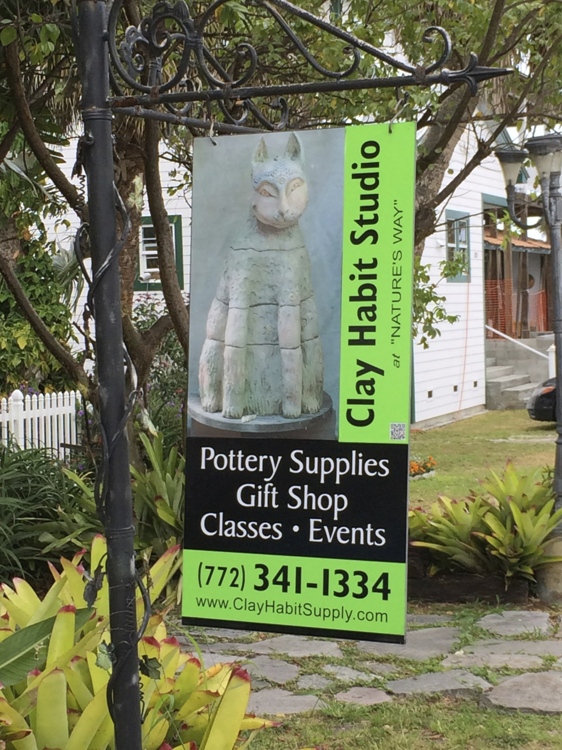
Jensen Beach, Florida, a small community located on the east coast of Florida, has always been known for its beaches and quaint historical downtown district filled with small shops, restaurants, and businesses. In 2004, the area was devastated by two major hurricanes that hit within a ten-day period. As a result, the small community had to rebuild and a conscious effort was made to restore the downtown to its original “old Florida” flair. Unfortunately, many businesses were forced to close their doors and others took years to renovate and repair their structures. Clay Habit Studio, owned and operated by Mia Lindberg, rebuilt and now provides the town with quality educational instruction and supplies for the clay art industry.
Supporting Literature
The first step I took to prepare for the observation at Clay Habit Studio was to study their website (Clay Habit Studio & Supply, 2014). This gave me a basic overview of the organization, background, services, and activities. I was encouraged that Clay Habit offered open studio days as well as classes. In addition, I learned that they were also involved with area schools. Although some of the links were still under construction, the website gave me basic information that was helpful for my case study.
Another website that provided beneficial information for my case study was The Arts Council of Martin County website (The Arts Council, Inc. 2014). This organization established a public art program in 1997 that provides funding for artworks that are located in public areas throughout Martin County. A nine volunteer committee, appointed by the Martin County Board of County Commissioners, determines a theme or purpose for the artwork and selects an artist from submitted applications. Lindberg (the owner of Clay Habit Studio & Supplies) was selected and given substantial funding to work with Jensen Beach High School art students and their art teacher on the SEA project, a mosaic sculpture of loggerhead sea turtles. The project took three years to complete and was installed in December of 2011.
Additionally, I read the article Art Education in Action on the Street (Chung, 2011). In this article, Chung and Ortiz discuss the importance of “showcasing art in the public sphere.” They believe that “increased art visibility and recognition is vital for the survival of art education in the public school system…and partnership with local community organizations is essential” (p 46). This information supported my selection of Lindberg and Clay Habit Studio for my case study. It confirmed her commitment and understanding of the importance of engaging students in art projects that impact the community and are done outside the school walls.
Finally, to prepare myself before my first interview with Mia Lindberg, I read an article by Ann Williams, the Senior Writer and Regional Editor for National Geographic magazine, called The Art of the Interview. In this article Williams breaks down an interview into five steps, the plan, the questions, listening, recording, and telling the story. Going through this enabled me put together a checklist. It helped me stay focused and stay on track as I conducted my interview with Lindberg.
Overview
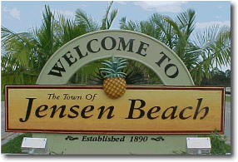
Clay Habit Studio is located in a small residential/business district comprised of older Florida style homes which is part of the historical downtown district of Jensen Beach, Florida. The town has a population of approximately eleven thousand and is nestled along the Indian River Lagoon and the Atlantic Ocean (Jensen Beach, Florida 2014). It is roughly one hundred miles north of Miami.
Clay Habit started with making and supplying wind chimes for Publix Supermarkets over thirty-five years ago. Eventually a studio and kiln opened for area artists to use and classes were offered. In 2001, Clay Habit became a distributor for Axner Clay Company and a general store was added to provide supplies for area schools, studios, and local potters. The business is funded through classes and sales.
Today, the owner and teacher, known to everyone only as Mia, teaches classes on Tuesdays and Thursdays. Wednesdays and Fridays are open studio days and summer camps are held for children. The general store is open Tuesday through Friday and appointments can be made for Saturday. Both local and visiting artists also hold workshops throughout the year.
Lindberg’s mission is to serve and support the art community with sales and delivery of clay and related products, and to offer a place where visitors, retail customers, students, studio potters, and sculptors can enjoy the freedom to find their own inspiration in a relaxed tropical atmosphere while enjoying top quality instruction and product demos (Clay Habit Studio & Supply, 2014).
Description and Discussion
My first visit at Clay Habit Studio was to interview Mrs. Lindberg on the afternoon of March 21st. The visit lasted approximately one and a half hours. When I arrived I found Mia’s studio surrounded by native landscape, clay sculptures, blown glass artwork, and a fence with locked gates. I had to call to come in the gate. I soon found out that regular patrons know where the key is hidden, but for others a phone call is necessary to come in.
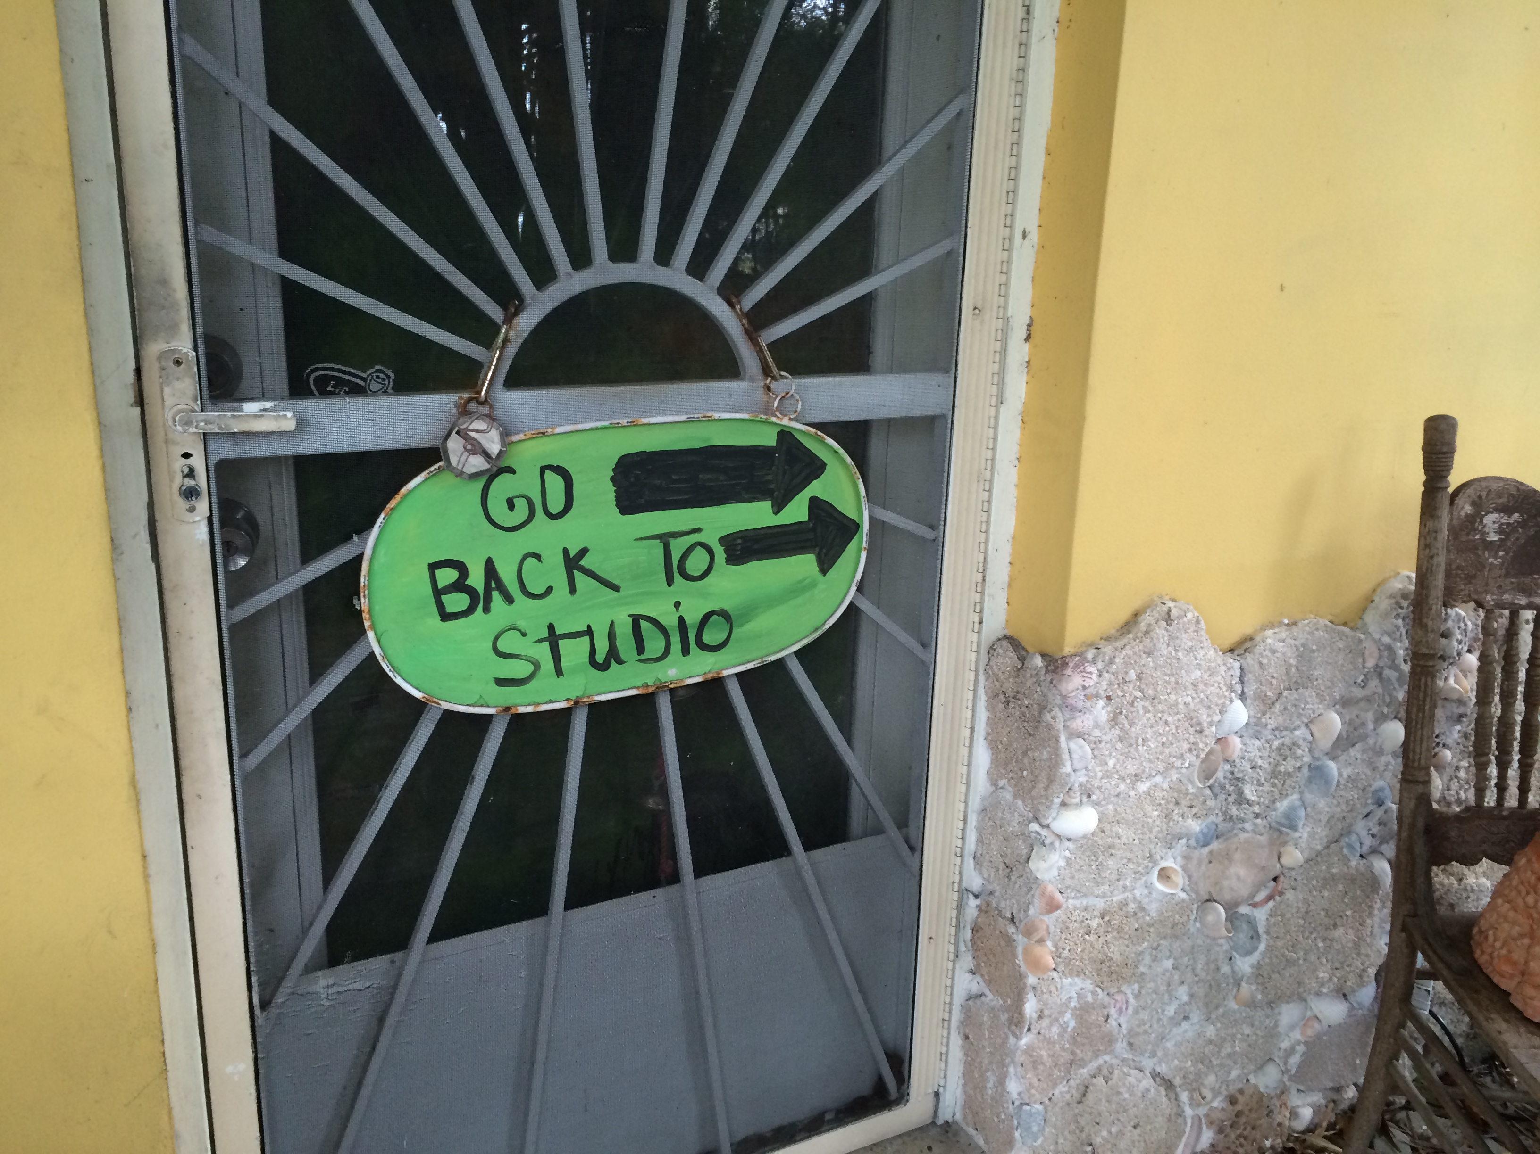
Upon entering, signs direct you along the rock, shell, and concrete walkway to the backyard. This is where you will find Mia, surrounded by handmade artwork, pottery, and supplies. Quickly you come to realize that Clay Habit Studio is not just another pottery studio.
As I came around to the back studio, Mia was explaining and demonstrating a sanding technique to a student. Once the student understood the process and could continue on her own, Mia took me on a tour and we sat down in the studio and talked about her beliefs and her business.
It came out during our conversation that Mia struggled with cancer. Immediately we had a connection and part of our conversation focused on running a business and dealing with cancer at the same time. She explained that for her every day is a blessing and an opportunity to share her gift with others. With that said, she also explained that she is very selective with who she accepts as regular students. They must listen and want to learn. If she feels in any way that someone may create distractions or disruptions, she only takes them on a trial basis.
With a large amount of rain over the week, my second visit to Clay Habit was rescheduled to March 27th. I attended a class at the Studio that lasted for two and a half hours. I was able to observe a class of senior women, all working on different projects. The information I gathered came from watching, listening, note taking, and photographing. With only a few open-ended questions the women willingly shared their opinions and thoughts.
I learned that Clay Habit is more than a pottery class for these ladies, it is a refuge, a haven where they have the opportunity to learn from a skilled, educated and gifted teacher.
If you listen carefully to the conversations during one of Mia’s classes you will hear students make comments like these:
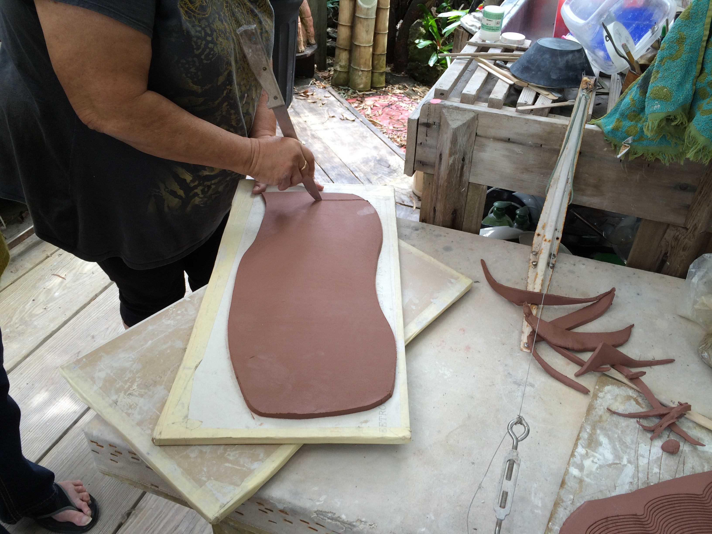
“You better listen, she knows what she is doing.”
“She never measures anything and it comes out perfect every time. I would have my ruler out measuring this and that. Not Mia, and look.”

“Mia, I’m not sure what to do with this mermaid’s tail. Suggestions?”

“I like it like it is, but if Mia says it needs more black paint, then it needs more black paint.”

“You know she is the best around.”
The conversations give a clear perspective of the student’s respect for Mia’s instruction and knowledge. But, it is not only about Mia’s teaching, her student’s genuinely love her.
“Mia, did you see Shakira on The Voice this week? I know how you love her!”
“Yes, yes, yes – her new album is already #2.”“No it’s #1!”
“You know where she got, my hips don’t lie? If the music isn’t good her hips won’t move.”

“Mia did you get your truck back yet?”
“No not yet. I’ve been walking everywhere. Look, I’ve worn my sneakers out. I need to
go to Kohls.”
“Get your purse. I’ll take you.”

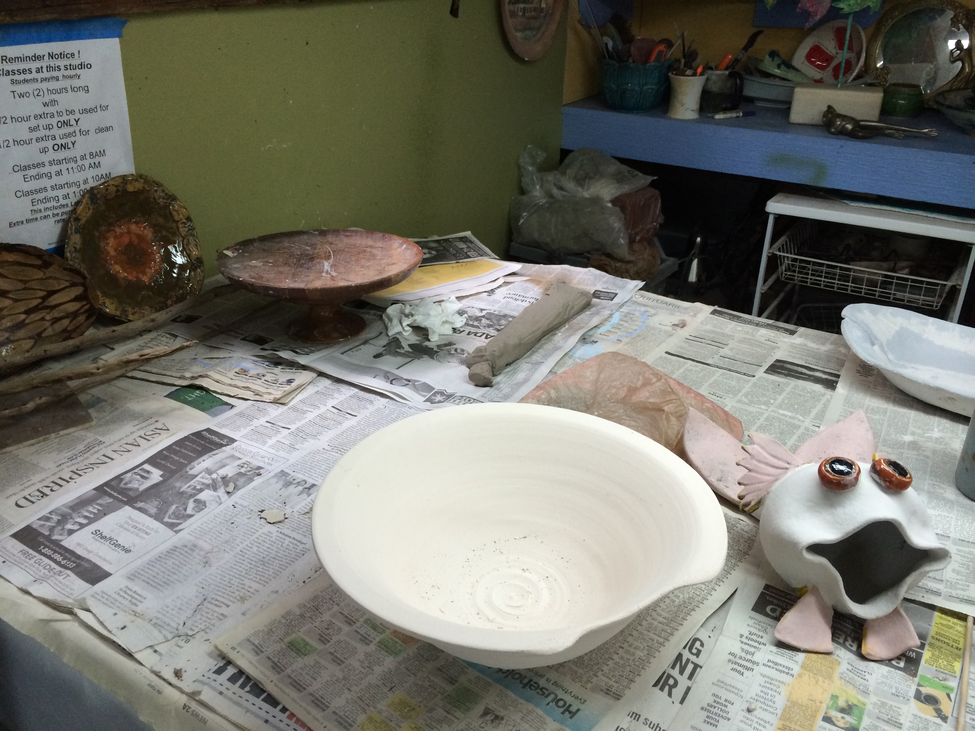
On March 31st I attended an open studio that Lindberg suggested I check out. I was there for a little over an hour and observed two women, both senior citizens. Candy and Susan attend the studio one to two times a week. Both women were eager to share and show me pieces that they had made. Again, the conversations revealed not only their love for the place but also their love for each other and appreciation for the friendships.
“It’s not only about the pottery, as you can see we are very social here.”

“Did you see my unconventional teapot? The spout bent down when we fired it but I love it anyway.”

Implications for the Field of Art Education
I left Clay Habit the first time and wanted to come home and build a studio in my backyard. It is an amazing place and it is obvious that Lindberg researched and put a lot of thought into it. The intentionally planned peaceful setting played an important part in the creative atmosphere of the studio. From our conversations, I also detected that Lindberg has made changes along the way to improve and develop a unique learning environment. Her efforts have been successful and her mission has been met, thirty-five years in business can attest to that. This prompted me to investigate further into the design and creation of a studio.
In addition, it was obvious that a teacher’s passion and love for what she does plays an important role in the success of a program. Her students felt her attitude and in return they respected and admired her. After visiting you would agree, Clay Habit Studio is not just another pottery studio. It is a refuge, a haven. Clay Habit is unique. It is a place where education and instruction are priorities, a place where students are excited to learn, and also a place where friendships are built.

References
The Arts Council, Inc. (2014). Arts In Public Places. Retrieved from
http://www.martinarts.org/programs/arts_in_public_places.html
Chung, S. and Ortiz, C. (2011). Art education in action on the street. Art Education,
64(3), 46-52.

Clay Habit Studio & Supplies. (2014). Retrieved from
http://www.clayhabitsupply.com/index.html
Jensen Beach, Florida. (2014). Retrieved from http://www.jensenbeach.com
Williams, Ann. (2005). The Art of the Interview. Retrieved from
http://www.nationalgeographic.com/xpeditions/lessons/09/g35/interviewingguidestudent.
pdf

